Session 2026-2027

Vision:Dream of where you want. | Mission: Means to achieve Vision

Program Educational Objectives of the program (PEO): (broad statements that describe the professional and career accomplishments)
PEO1 | Preparation | P: Preparation | Pep-CL abbreviation  pronounce as Pep-si-lL easy to recall
PEO2 | Core Competence | E: Environment (Learning Environment) | Pep-CL abbreviation  pronounce as Pep-si-lL easy to recall
PEO3 | Breadth | P: Professionalism | Pep-CL abbreviation  pronounce as Pep-si-lL easy to recall
PEO4 | Professionalism | C: Core Competence | Pep-CL abbreviation  pronounce as Pep-si-lL easy to recall
PEO5 | Learning Environment | L: Breadth (Learning in diverse areas) | Pep-CL abbreviation  pronounce as Pep-si-lL easy to recall

Program Outcomes (PO): (statements that describe what a student should be able to do and know by the end of a program)
Keywords of POs:
Engineering knowledge,Problem analysis, Design/development of solutions,Conduct Investigations of Complex Problems, Engineering Tool Usage, The Engineer and The World,Ethics, Individual and Collaborative Team work,Communication, Project Management and Finance, Life-Long Learning

PSO Keywords: Cutting edge technologies, Research

“I am an engineer, and I know how to apply engineering knowledge to investigate, analyse and design solutions to complex problems using tools for entire world following all ethics in a collaborative way with proper management skills throughout my life.” to contribute to the development of cutting-edge technologies and Research.

Integrity: I will adhere to the Laboratory Code of Conduct and ethics in its entirety.

Name and Signature of Student and Date
(Signature and Date in Handwritten)

Session | 2024-25 (ODD) |  | Course Name | Web Technology Lab
Semester | 3 |  | Course Code | 23CT1301
Roll No | 79 |  | Name of Student | Gaurav Pekde
Practical Number
Course Outcome |  | - Understand various internet technologies.  - Design the web pages using HTML and CSS.  - Implement the XML technology to store the data.  - Develop the interactive web pages using JavaScript.
Aim |  | To implement the logic of a to-do list in TypeScript using an interface and typed functions, to add, toggle (complete) and delete tasks.
Problem Definition |  | Create a Task interface with the fields id (number), title (string) and completed (boolean). Using this interface, write typed functions addTask, toggleTask and deleteTask that manage an array of tasks. Show the result in a web page built with HTML, CSS and TypeScript, and show that TypeScript reports an error when the wrong type is passed.
Theory  (100 words) |  | TypeScript is JavaScript with static types. Types are checked before the code runs, so mistakes such as passing a number where a string is expected are caught early. An interface describes the shape of an object. Here, the Task interface defines id, title and completed. Functions use typed parameters and return types. For example, addTask(title: string): void takes a string and returns nothing. The array Task[] can hold only Task objects. The map() method creates a new array and is used to toggle a task. The filter() method keeps only the matching items and is used to delete a task. Browsers cannot run TypeScript directly, so Vite compiles it to JavaScript.
Procedure and Execution  (100 Words) |  | Step for Implementation:  - Create the project: npm create vite@latest partA -- --template vanilla-ts  - Run cd partA, then npm install.  - Create src/types.ts and define the exported Task interface.  - Create src/todoLogic.ts. Declare let tasks: Task[] = [] and write addTask, toggleTask (using map) and deleteTask (using filter).  - Write index.html with a heading, an input box, an Add button and an empty <ul>.  - Write src/style.css for the styling.  - Write src/main.ts to read the input, call the logic functions and redraw the list.  - Run npm run dev and open the localhost link.  - Test: add a task, click Complete, click Delete and try an empty input.
Code:
types.ts

export interface Task {
id: number; // number
title: string; // text
completed: boolean; // true / false
}

Todologic.ts

import type { Task } from "./src/types";

// Task[] = array that can hold only Task objects
let tasks: Task[] = [];

// (title: string) = typed parameter, : void = returns nothing
export function addTask(title: string): void {
const newTask: Task =
{
id: Date.now(),
title: title,
completed: false
};
tasks.push(newTask);
}

// map() goes through every task and flips completed for the matching id
export function toggleTask(id: number): void {
tasks = tasks.map((task: Task) => {
if (task.id === id) {
return {
...task,
completed: !task.completed
};
}
return task;
});
}

// filter() keeps every task except the one with this id
export function deleteTask(id: number): void {
tasks =
tasks.filter((task: Task) =>
task.id !== id
);
}

// helper so the page can read the current tasks
export function getTasks(): Task[] {
return tasks;
}

Main.ts

import "./style.css";
import { addTask, toggleTask, deleteTask, getTasks } from "./todoLogic";
import type { Task } from "./src/types";

const input = document.getElementById("taskInput") as HTMLInputElement;
const addBtn = document.getElementById("addBtn") as HTMLButtonElement;
const list = document.getElementById("taskList") as HTMLUListElement;

// Draws the task list on the page
function render(): void {
list.innerHTML = "";

getTasks().forEach((task: Task) => {
const li = document.createElement("li");

const span = document.createElement("span");
span.textContent = task.title;
span.style.textDecoration = task.completed ? "line-through" : "none";

const completeBtn = document.createElement("button");
completeBtn.textContent = "Complete";
completeBtn.onclick = () => {
toggleTask(task.id);
render();
};

const deleteBtn = document.createElement("button");
deleteBtn.textContent = "Delete";
deleteBtn.onclick = () => {
deleteTask(task.id);
render();
};

li.append(span, completeBtn, deleteBtn);
list.appendChild(li);
});
}

// Add button
addBtn.onclick = () => {
if (input.value.trim() === "") {
return;
}
addTask(input.value);
input.value = "";
render();
};

render();

Output:
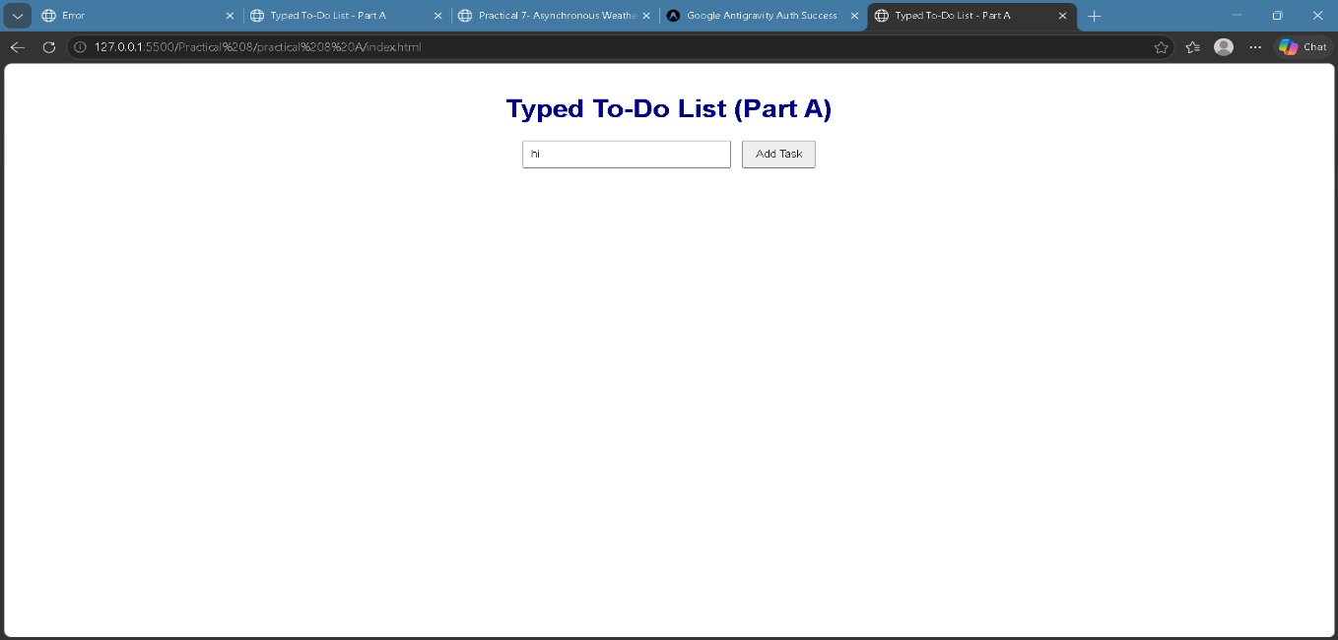
Output Analysis
Link of student Github profile where lab assignment has been uploaded |  | https://github.com/gauravpekde-sys/Web-Technology.git
Conclusion |  | The to-do list logic was implemented in TypeScript using the Task interface and typed functions. Static typing caught wrong data types before the program ran, which made the code safer and easier to maintain. The map() and filter() methods allowed tasks to be toggled and deleted without changing the original array directly. The same Task interface can be reused in Part B with React.
Plag Report (Similarity index < 12%)
Date |  | 09/10/2026

